University of Regina

ENSE 400/477

Project Startup



**Project Night Terror Requirements & Specifications**



*Author: Advisor:*

Evan Geissler Dr. Christine Chan

February 2019

**Table of Contents**

**1 Introduction………………………………………………………………………………….…......1**

1.1 Purpose.............................………………………………..………………..........………....…1

1.2 Scope........................................……………..…………………………………….........…...…1

1.2.1 In Scope........................................…………………………………….........…...…1

1.2.2 Out of Scope..…………………………..............................………….........…...…1

1.3 Main Objectives and Success Criteria……….………………..............................…1

1.4 Secondary Objectives..…………...........................................………….........…........…2

1.5 Constraints..…………................................................................………….........…........…3

1.6 Overview..………….......................................................................………….........….....…3

**2 Proposed Project..........………….………………...…………….....……………………………3**

2.1 Functional Requirements**.………………...…………….....………………........……3**

2.2 Non-functional Requirements**.………………...…………….....…………….........4**

2.3 Software Requirements**.………………...…………….....…………………………….4**

2.4 System Models**.………………...…………….....………………………….................…5**

2.4.1 Scenarios**.………………...…………….....………………………….............…5**

2.4.2 Object Model**.………………...…………….....…………………………….......5**

2.4.3 User Interfaces & Menus**.………………...…………….....………………...8**

**List of Figures**

Figure 2.4-1. Basic Flowchart of the Game…………………………………………………...............5

Figure 2.4-2. Character Class Diagram………………………………………………….......................5

Figure 2.4-3. Collectable Class Diagram…………………………………………………....................6

Figure 2.4-4. Weapon Class Diagram…………………………………………………............................7

Figure 2.4-5. Example of Perk Trees………………………………………………….............................7

Figure 2.4-6. Basic HUD…………………………………….........……………………………………..........8

Figure 2.4-7. Main Menu…………………………………….........……………………………………........8

Figure 2.4-8. Item Menu…...………………………………….........……………………………………......9

Figure 2.4-9. Pause Menu…………………………………….........……………………………………......9

**List of Tables**

Table 2.1-1. Shooting a Weapon……………….....…………………………………………………......3

Table 2.1-2. Picking Up an Item or Collectable…......…………………………………………......3

Table 2.1-3. Saving & Loading…………………………..............................................……………......4

Table 2.2-1. Head Up Display…......…………….....................…………………………..............…......4

Table 2.2-2. Menus…......…………….....................……....................……………………..............…......4

**1 Introduction**

* 1. **Purpose**

The purpose of this project is to create a twisted, scary, and enjoyable gaming experience in a first person perspective.

**1.2 Scope**

**1.2.1 In Scope**

This project will have two non-playable characters (NPCs); one that guides the player and one that is the main antagonist. Along with these two, there will be enemy NPCs that will challenge and/or attack the player and passive ghost NPCs. The enemy NPCs will consist of at least 3 different demon characters that are all affected by light to some degree. The NPCs will also have varying levels of AI depending on their purpose.

The playable area will be a landscape similar to Qu’Appelle Valley, Saskatchewan and will also include interiors and/or exteriors of popular haunted buildings inspired by different areas in Qu’Appelle Valley.

The game will have items such as a gun, flashlight, or cross. These are used to defeat enemies and aide the player. These items and the player’s health will be upgradable by finding collectables in different areas.

Also in the scope of the project will be dynamic menus, i.e. menus that change, as the player progresses and also the ability to save the game. Music and sound effects will be added to enhance the over experience. Sub objectives will also be used to add to the story and add a means of getting an upgrade. The story will be told by NPCs, collectibles, etc. The collectibles will be audio files, letters, items, etc.

Finally, accessibility options will also be added to allow for subtitles, brightness changes, speed of the playable character, etc. to allow for a user-friendlier gameplay.

**1.2.2 Out of Scope**

This project will not include any form of multiplayer. The project will also have a limit on quality of graphics, number of assets, in depth voice acting, sound track, etc.

**1.3 Main Objectives and Success Criteria**

1. Realistic Landscape & Environmental Creation
   1. Key buildings with interiors and/or exteriors
   2. Qu’Appelle Valley area
2. Two main Non-Playable Characters (NPCs)
   1. Passive ghost (guides player)
   2. Mostly passive demon (main antagonist)
   3. Multiple NPC with Varying AI
   4. Passive NPC mostly minimum AI (walking around, etc.)
   5. Various Enemy AI levels (Attacks, abilities, etc.)
3. Dynamic menus such that it changes as player progresses Ex. Main Menu environment changes from sunny to stormy
4. Multiple items (flashlight, pistol, etc.)
5. Upgradable Items
   1. Optional (Can complete game without them)
   2. Usually obtained in side objectives
   3. 0 to 3 upgrades per item
6. The ability to save progress and return to that point without penalty
7. Start to Finish Aspects
   1. Main menu
   2. Opening
   3. Main Game
   4. Credits
   5. Some Music & Sound Effects
8. Collectables
   1. Letters, texts, messages, etc.
   2. Objects that relate to area
9. A set of main and side objectives

**1.4 Secondary Objectives**

1. Easter eggs & references
2. Trophies, achievements, etc.
3. Create a multiplatform game, i.e. for Xbox One, PS4, etc.
4. New game+ (second play through)
   1. Harder and different NPC AI
   2. Level changes
5. Complete Set of Music & Sounds
6. Voice Acting
7. More Items
8. Better Details
   1. Environment (Nicer grass, water, etc.)
   2. Items (Intricate design)

**1.5 Constraints**

Constraints of the project include time to complete tasks, having to learn new or more in-depth tools, money, etc. To limit strain of constraints the project will be designed while also watching tutorials, using free programs, using easy to use programs, and using helpful software.

**1.6 Overview**

Project Night Terror is a first person realistic horror game that will allow players to experience a story driven game from start to finish. The player will be able to find collectables, items, and different leveled non-playable characters. The game is based around ghost stories, real locations, and/or fictional events in Saskatchewan.

**2 Proposed Project**

**2.1 Functional Requirements**

***Table 2.1-1. Shooting a Weapon***

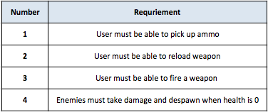

***Table 2.1-2. Picking Up an Item or Collectable***

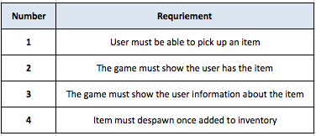

***Table 2.1-3. Saving & Loading***

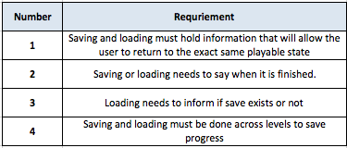

**2.2 Non-functional Requirements**

***Table 2.2-1. Heads Up Display***

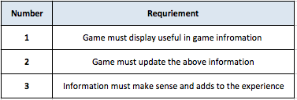

***Table 2.2-2. Menus***

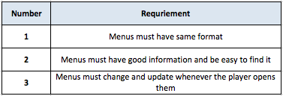

**2.3 Software Requirements**

The only main requirements needed for the project is an easy to use game engine. For this project, Unreal Engine 4 will be used.

**2.4 System Models**

**2.4.1 Scenarios**

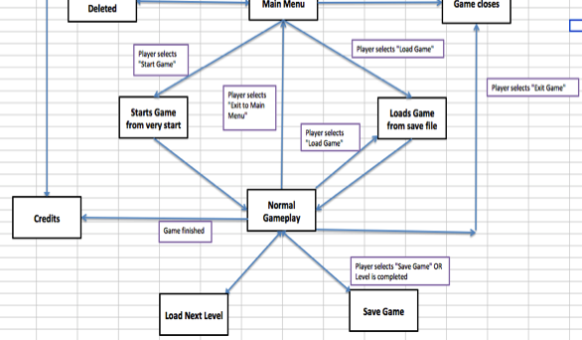

***Figure 2.4-1. Basic Flowchart of the Game***

**2.4.2 Object Model**

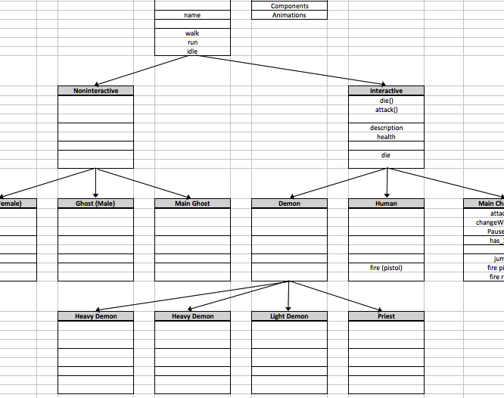

***Figure 2.4-2. Character Class Diagram***

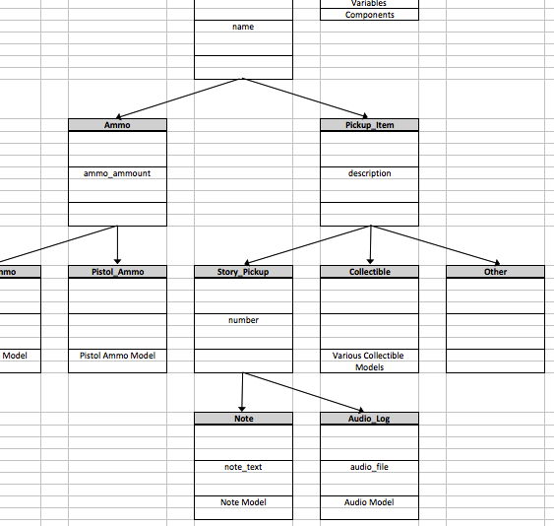

***Figure 2.4-3. Collectable Class Diagram***

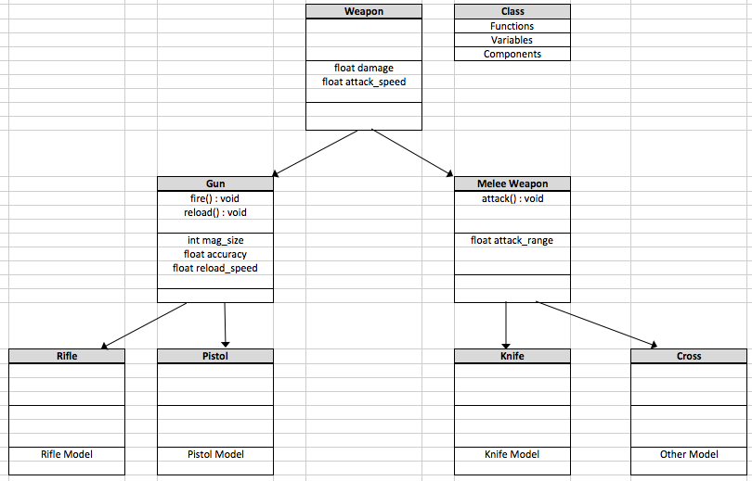

***Figure 2.4-4. Weapon Class Diagram***

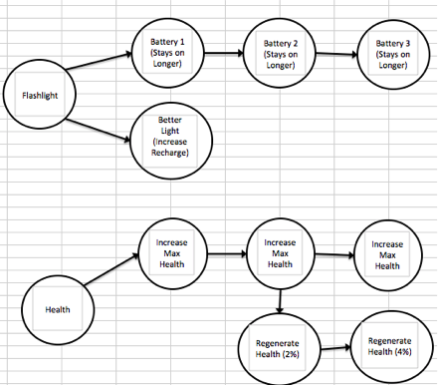

***Figure 2.4-5. Example of Perk Trees***

**2.4.3 User Interfaces & Menus**

This section gives a brief overview of the different user interfaces (UI) and menus the player will encounter.

The head up display (HUD) is what the player will see during most of the game, as it will be the information shown as they are playing the actual game. This includes health information, item information, and a motion sickness/aiming dot.

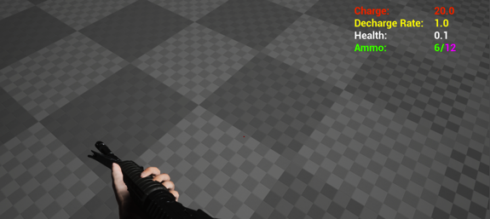

***Figure 2.4-6. Basic HUD***

The main menu is what the player will first see when the game is opened. The menu will allow the player to play a game from the start, load a saved game, delete a saved game, change settings, and exit the game.

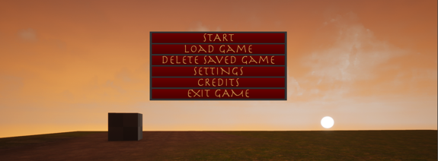

***Figure 2.4-7. Main Menu***

The item menu will let the player view information about objectives, items, collectables, and perks. The player will also be able to select perks from this menu.

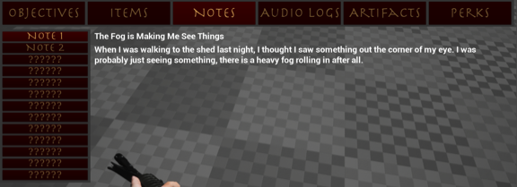

***Figure 2.4-8. Item Menu***

Pause Menu:

This menu will let the player save or load a game, view and change settings, exit to the main menu, and exit the game.

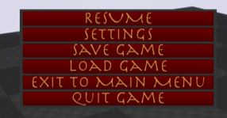

***Figure 2.4-9. Pause Menu***